ADITHYA R
192311369

Experiment – 13
Create a Virtual Machine with 1 CPU, 2GB RAM and 15GB storage disk using a Type 2 Virtualization Software using Vmware workstation.
Answer:
AIM: To create a VM with specific hardware configuration using VMware Workstation.
SOFTWARE REQUIRED: VMware Workstation 17, Ubuntu ISO, Host OS: Windows
PROCEDURE:
STEP 1: Launch VMware Workstation
Click Start → VMware Workstation 17

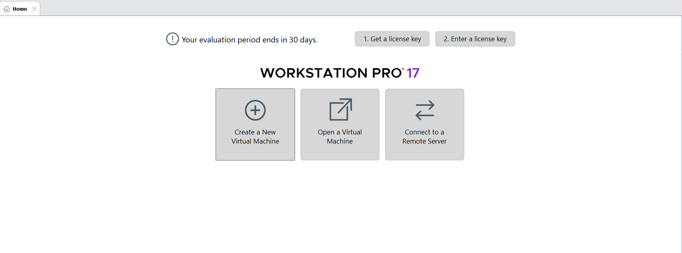

STEP 2: Create Virtual Machine
Click Create a New Virtual Machine
Select Typical (recommended) → Next
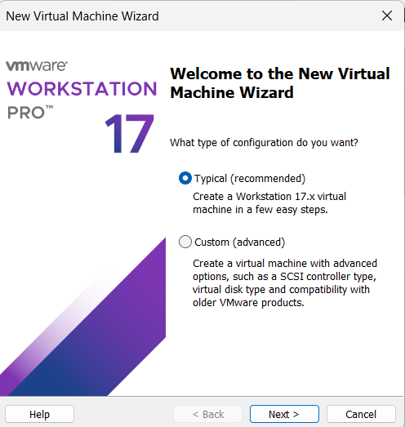

STEP 3: Select OS Installer
Choose Installer disc image file (ISO)
Browse and select Ubuntu ISO

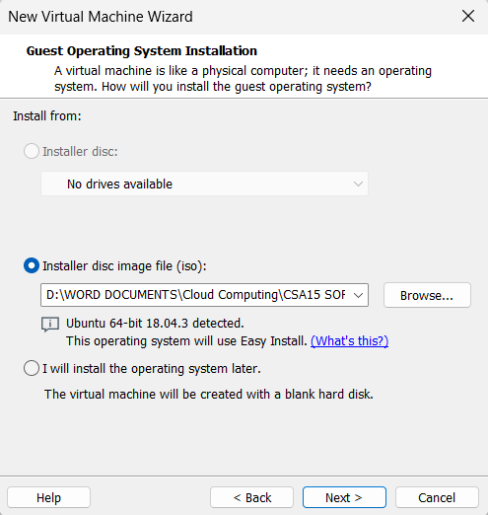

STEP 4: Name VM & Location
VM Name: Virtual Machine Ex-13
Choose location → Next
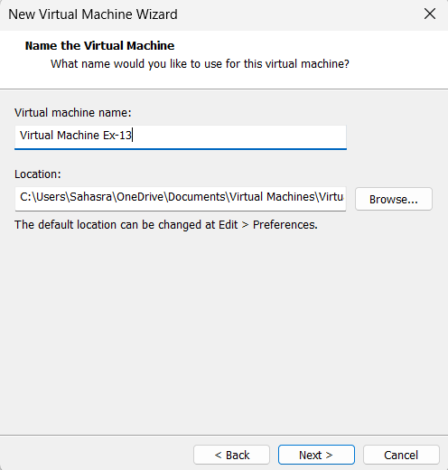

STEP 5: Configure Disk
Click Hard Disk
Set disk size to 15 GB
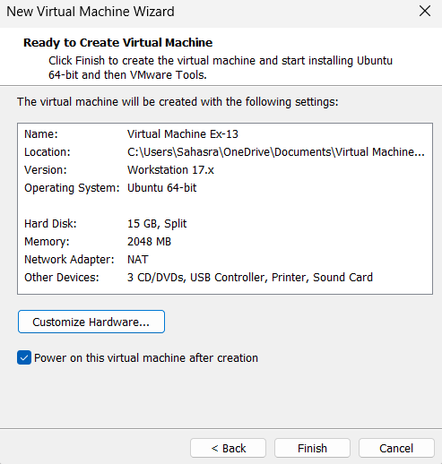
STEP 6: Configure Memory
- Click Memory
- Set memory to 2048 MB (2 GB)
Configure CPU
- Click Processors
- Set:
    - Number of processors: 1
    - Number of cores per processor: 1
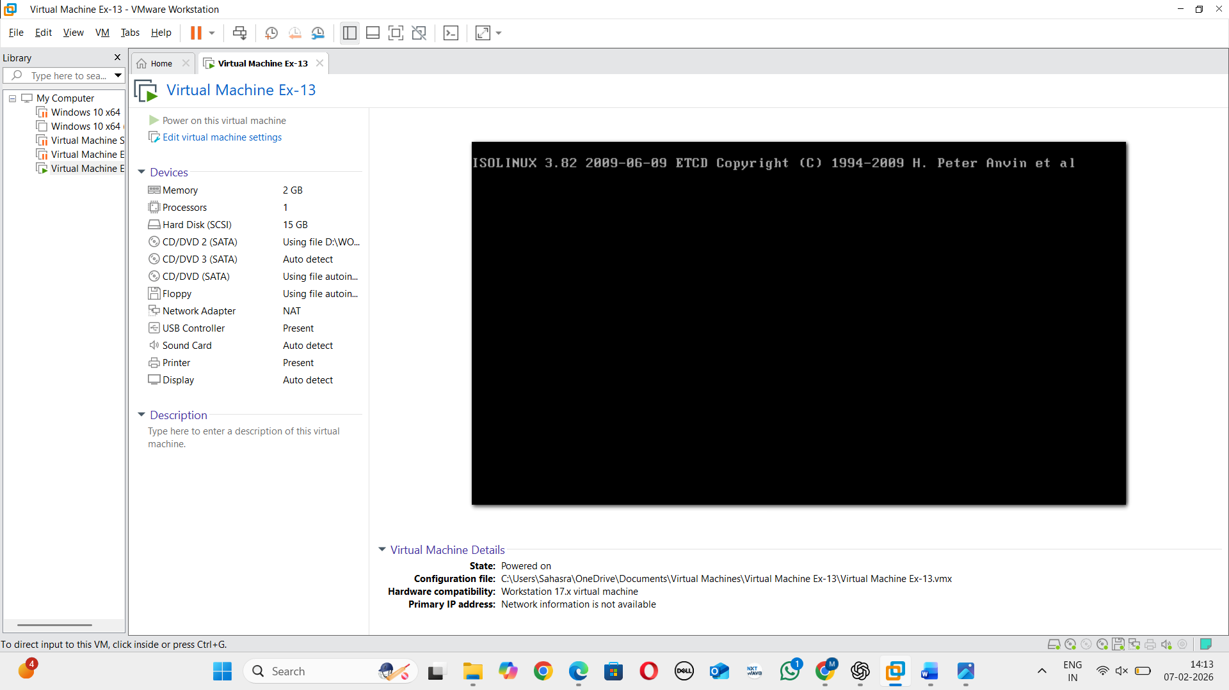
STEP 7: Save & Start VM
Click OK
Power ON the VM


RESULT: A virtual machine with 1 CPU, 2GB RAM and 15GB storage is created successfully.

